Abi Shilon: Trainer - Coach - Facilitator

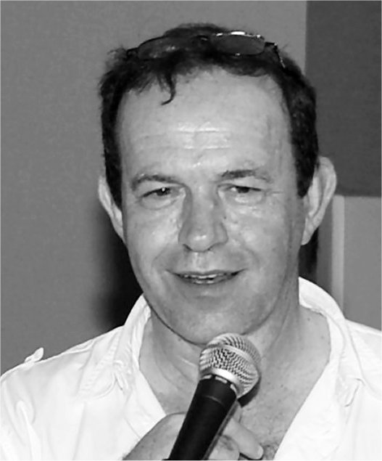 | Abi Shilon is a leadership and executive coach, coming from the hi-tech industry, trained by the Coaches Training Institute and the Center for Right Relationship, Accredited by the International Coach Federation and a faculty member of CTI – The coaches training Institute. Abi coaches leaders, managers and entrepreneurs since 2003. Abi also franchises CTI in Israel.  Prior to becoming a coach Abi managed groups in the defense and Telecom industry. Abi travels to train new coaches in Europe Asia and Africa, works with international companies based in Israel and involved in bringing coaching skills to students in universities.
Areas of Expertise | During his career Abi managed groups of different sizes in the high-tech industry, typically international telecommunication companies developing either equipment or software for local or international carriers (Harmonic Inc. ECI Telecom, Tadiran Telecom and others). Abi managed R&D groups, Marketing Groups and Business Development.  As a coach Abi works with entrepreneurs, in hi-tec organizations, with top and mid-level corporate managers and with community leaders. He also facilitates groups in effective leadership , communication skills and vision creation.
Education and Training | Abi has accomplished his basic training in Electrical Engineering B.ScEE in the Technion Technical University in Israel, Studied toward M.Sc and Mathmatics in Tel Aviv University and has an MBA cum laude from the University of Derby.  Abi studied and certified as a Co-Active Professional Coach (CPCC) in the Coaches Training Institute in California and received his PCC (Professional Certified Coach) accreditation from the International Coach Federation (ICF). Abi also graduated a 10 months Co-Active Leadership program in California, which prepared him to join the faculty of CTI as an international coach trainer. In addition Abi studied and is certified as systems and relationships coach ORSCC by CRR, the Center for Right Relationship and uses NLP and meditation techniques. Abi is also a seasoned clarinet player, playing chamber music with different amateur ensembles.
Professional Membership | Abi is a member of ICF, the International Coach Federation, a faculty member of the Coaches Training Institute, and certified as MCIL ( master coach) by the Israeli Coaches Chamber ("Lishkat Hameamnim")

